**POPUP Maintenance for Users Popup Menu**

The N-K-3 Popup Maintenance is the master file that ultimately allows each user to define their POPUP icon to show the files, reports, inquires and utilities that they most often use. Once defined, the user can access their favorites from any screen in Advantzware.

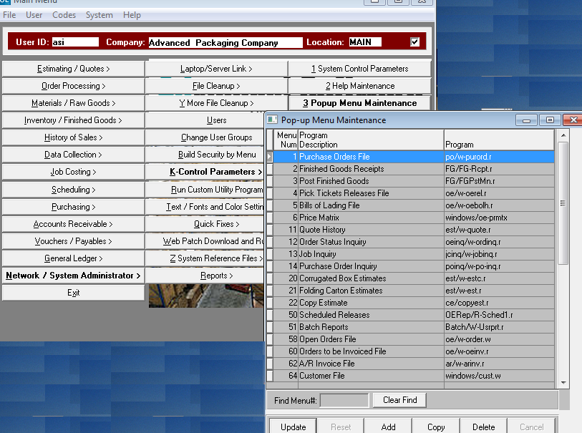

**Users Popup Menu**

Each user can define their own Popup Maintenance via the Network Users administration.

The systems administrator or each user with security can define what menu options and what order. It is best to delete all user menu options, then imports the NK1 master menu. Once defined, the icon for computer multitasking displays the menu options.

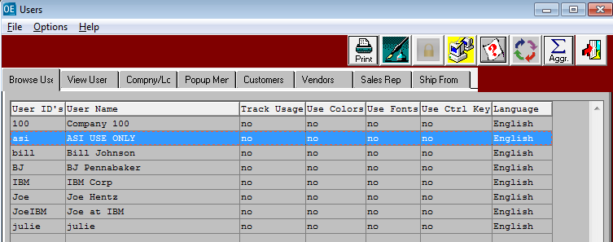

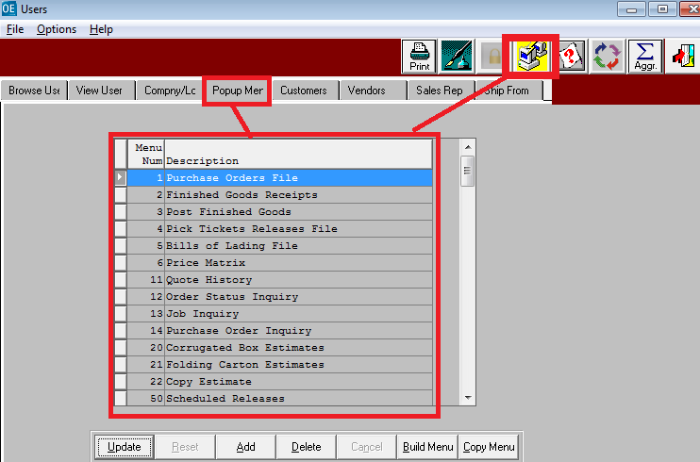

**Users Popup Menu**

Each user can define their own Popup Maintenance via the Network. The advantage is that the user can stay focused on the screen where they are working. For example, the user can Add order, create PO, print the PO, create release, print and post release, create load tags, view and post finished goods receipts, print the bill of lading and create the invoice all from order entry.

